Objective:

The goal of this data analysis task was to extract meaningful insights from the pizza sales dataset, providing key performance indicators (KPIs) and trends that can help in understanding and optimizing the business.

Dataset:

The dataset, named pizza_sales, contains information about pizza orders. Key columns include order_id, order_date, order_time, pizza_name, pizza_category, pizza_size, quantity, and total_price.

Link:

[Tableau Visualization](https://public.tableau.com/views/PizzaSales_17068099796240/Home?:language=en-GB&publish=yes&:display_count=n&:origin=viz_share_link)

Queries:

Below.[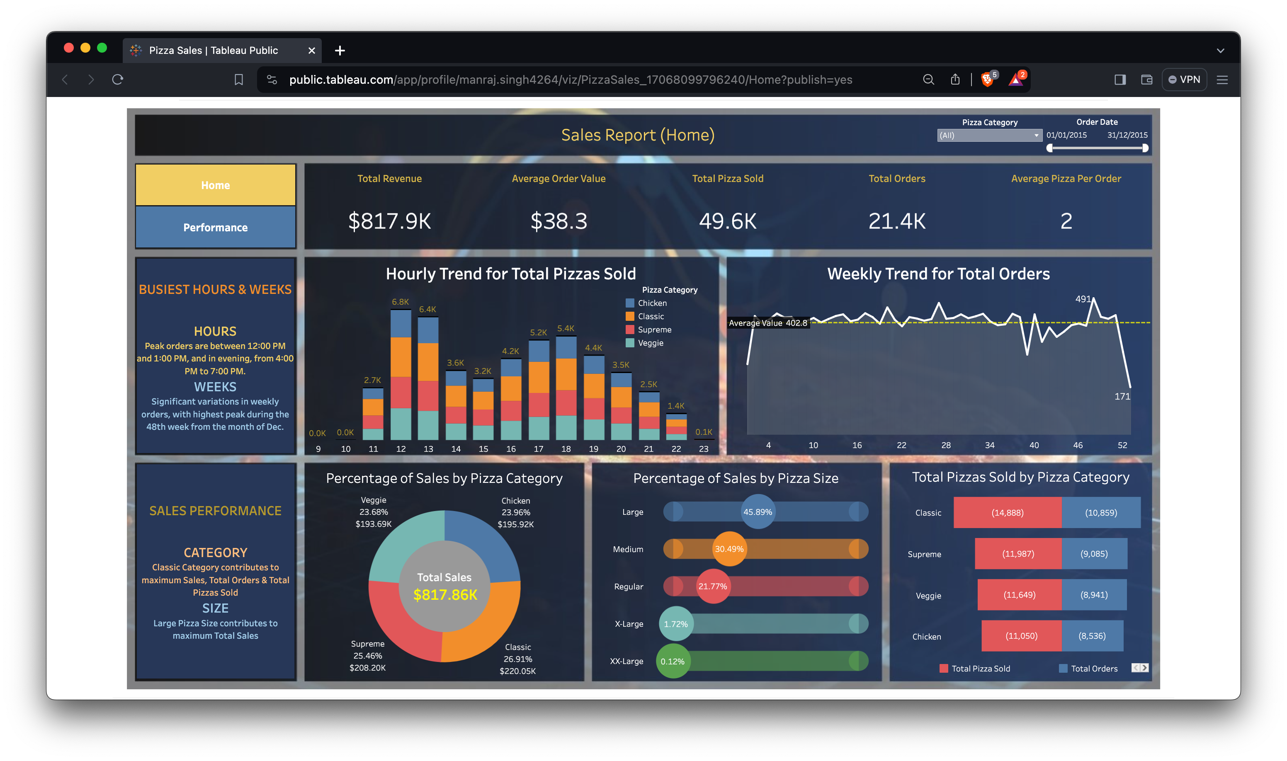](https://public.tableau.com/views/PizzaSales_17068099796240/Home?:language=en-GB&publish=yes&:display_count=n&:origin=viz_share_link)

PIZZA SALES SQL QUERIES

A. KPI’s

1. Total Revenue:

SELECT SUM(total_price) AS Total_Revenue FROM pizza_sales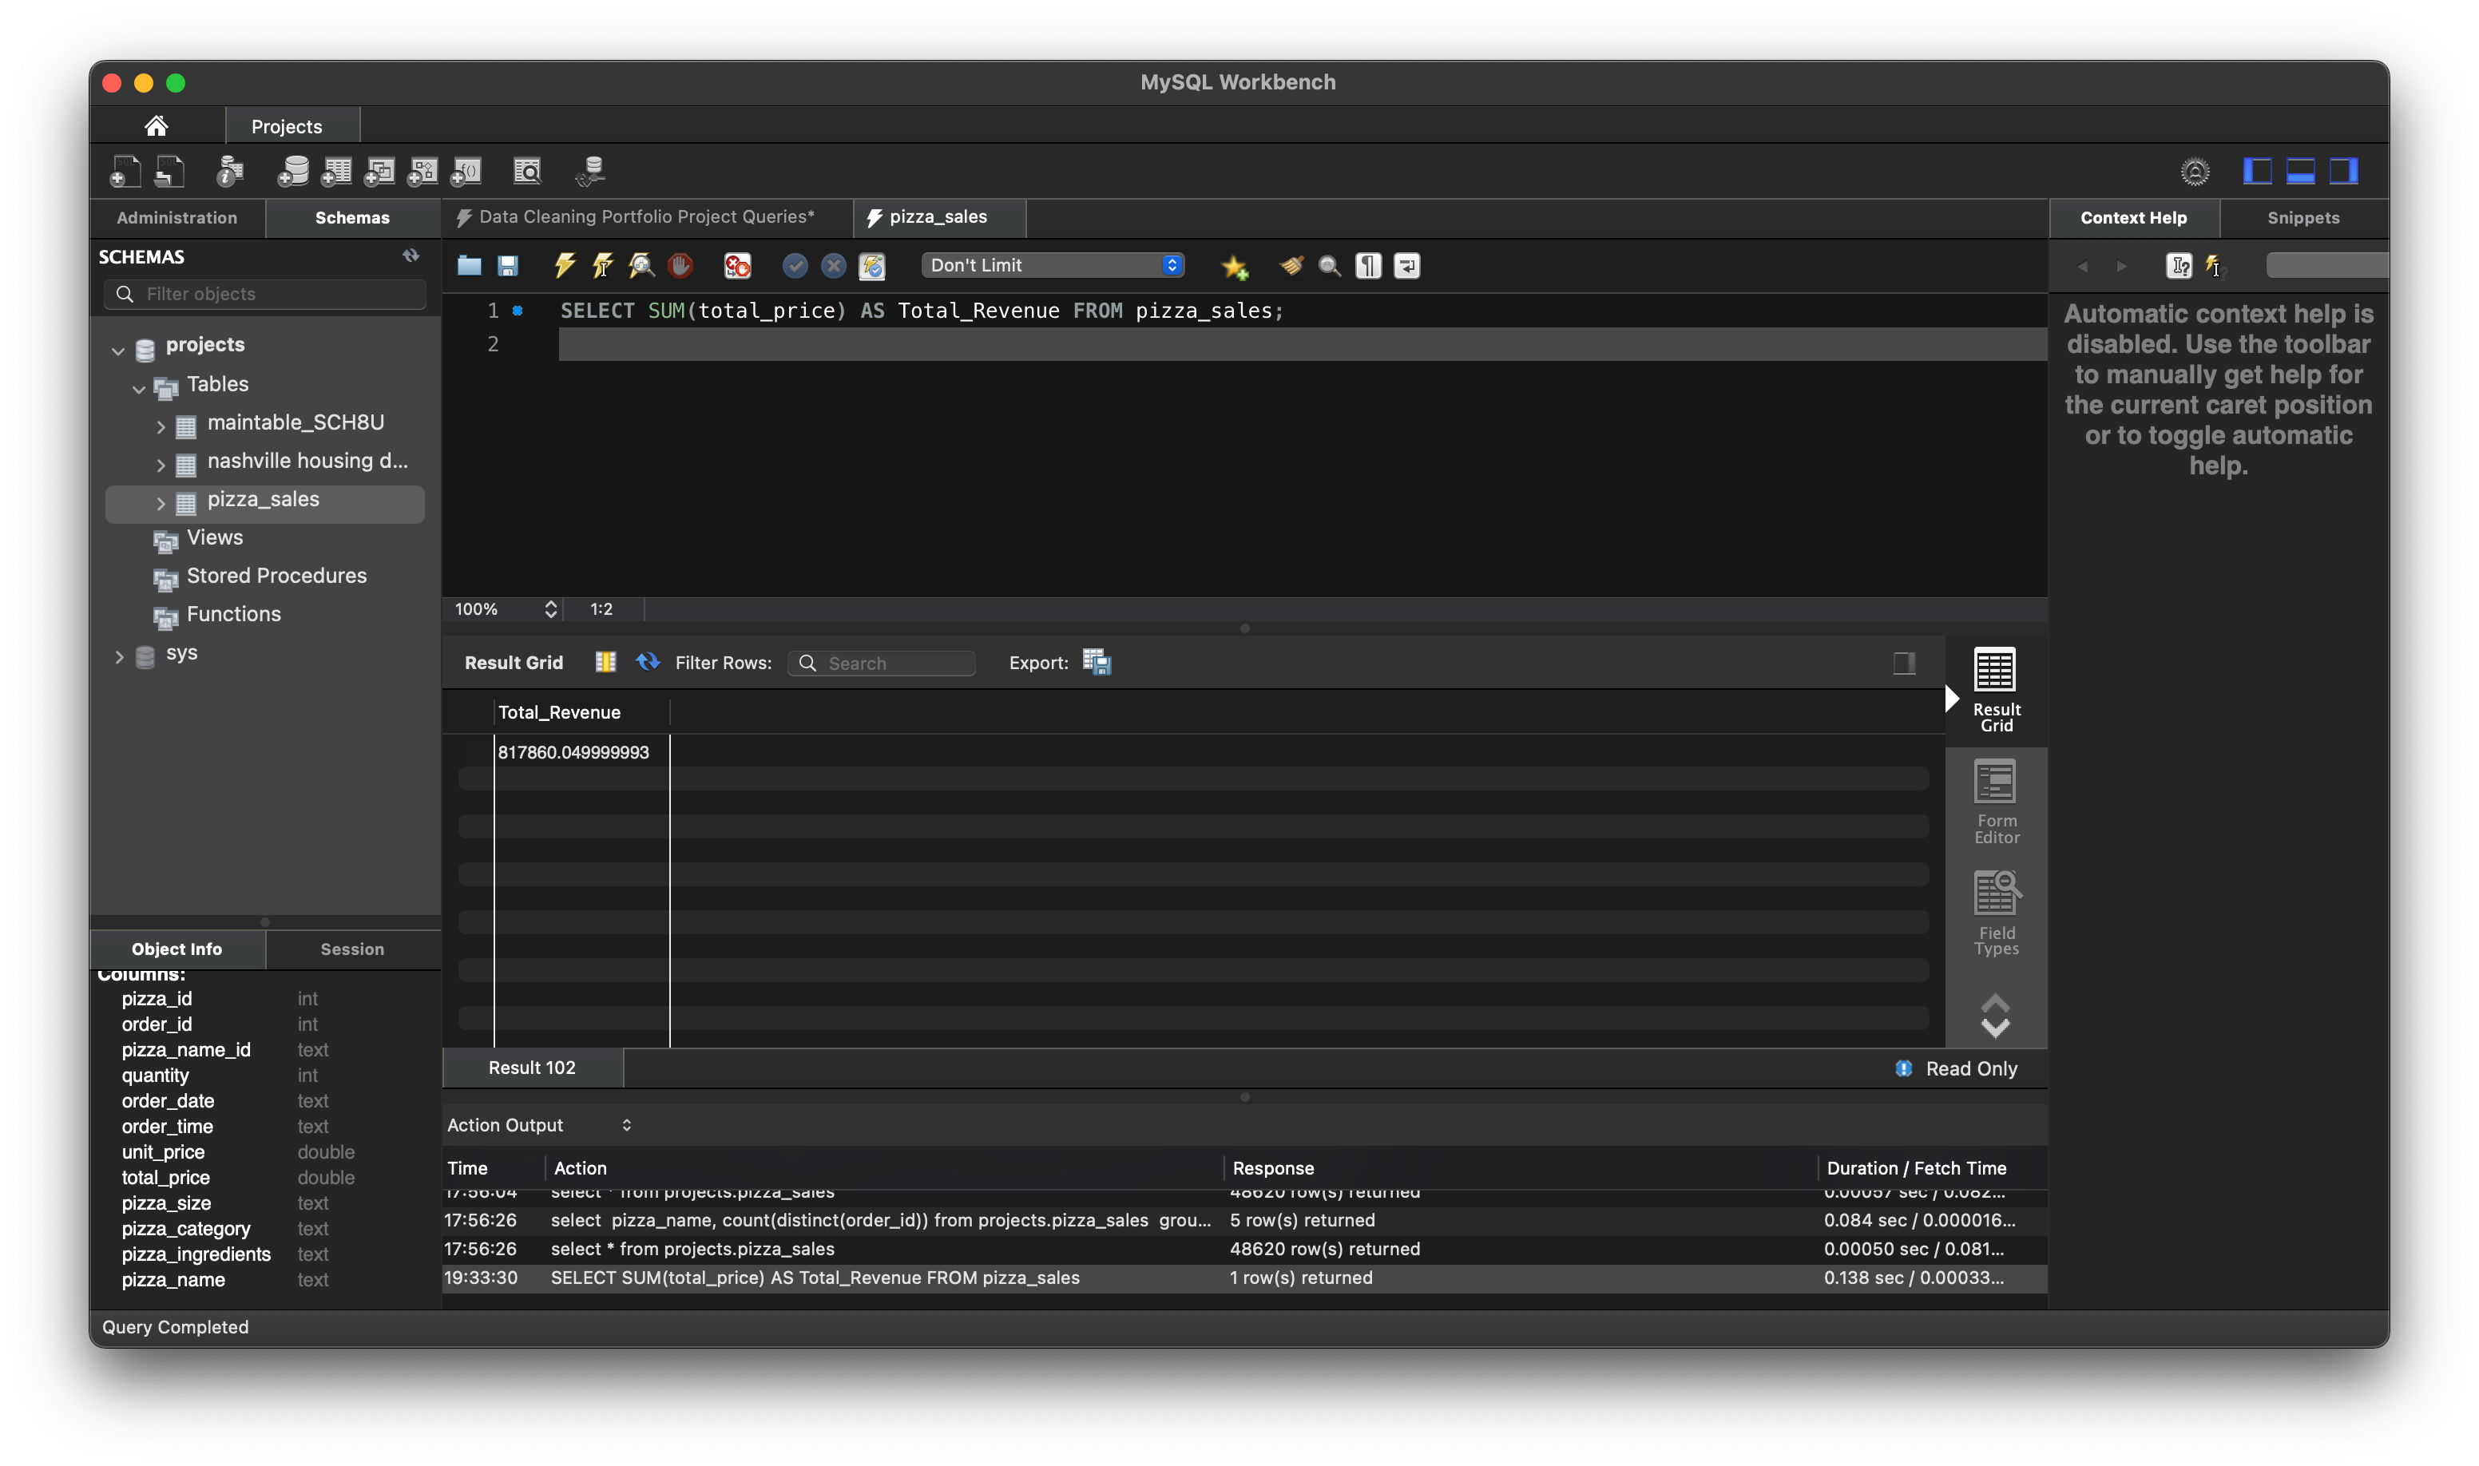

2. Average Order Value

SELECT (SUM(total_price) / COUNT(DISTINCT order_id)) AS Avg_order_Value FROM pizza_sales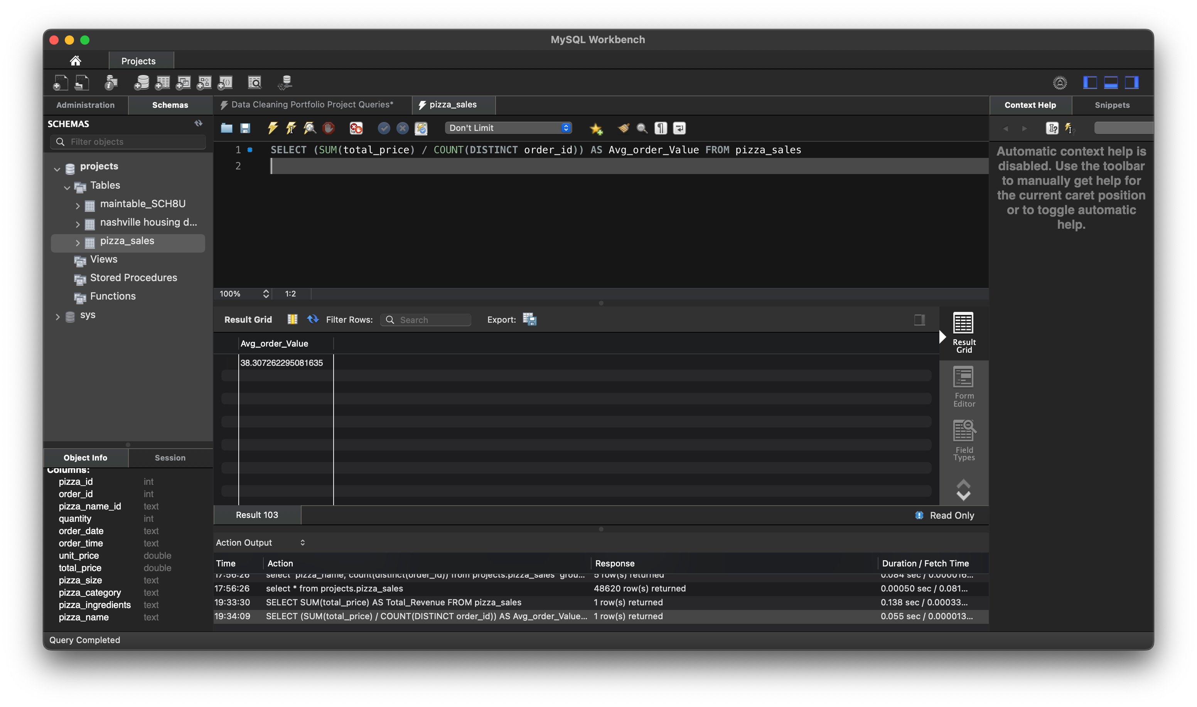

3. Total Pizzas Sold

SELECT SUM(quantity) AS Total_pizza_sold FROM pizza_sales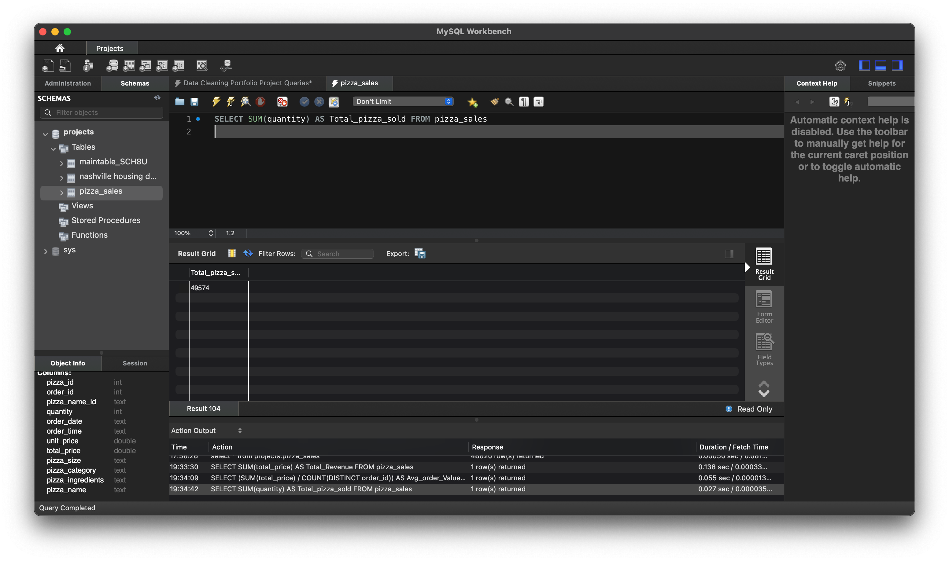

4. Total Orders

SELECT COUNT(DISTINCT order_id) AS Total_Orders FROM pizza_sales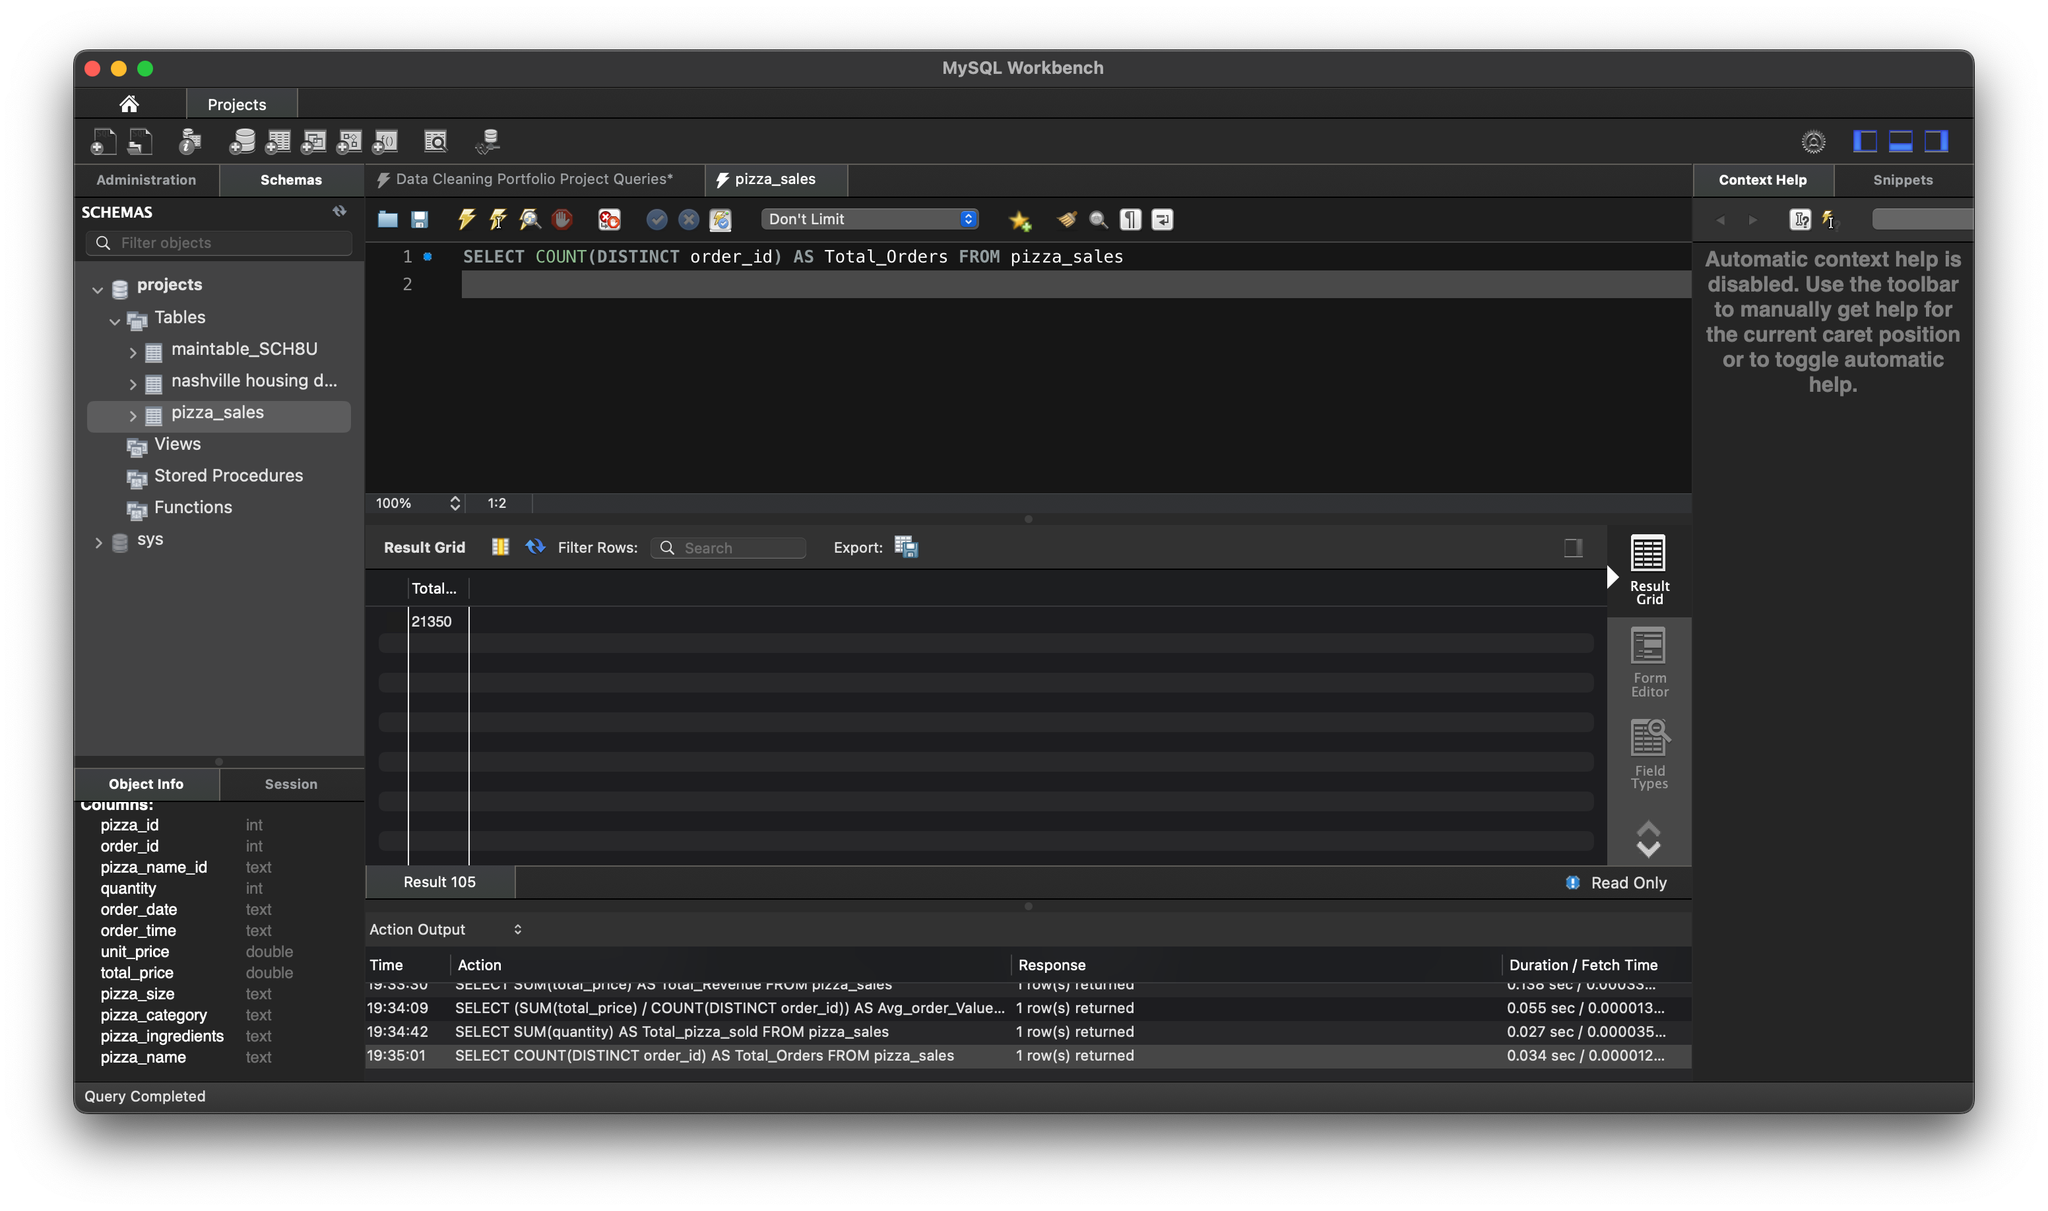

5. Average Pizzas Per Order

SELECT CAST(CAST(SUM(quantity) AS DECIMAL(10,2)) /

CAST(COUNT(DISTINCT order_id) AS DECIMAL(10,2)) AS DECIMAL(10,2))

AS Avg_Pizzas_per_order

FROM pizza_sales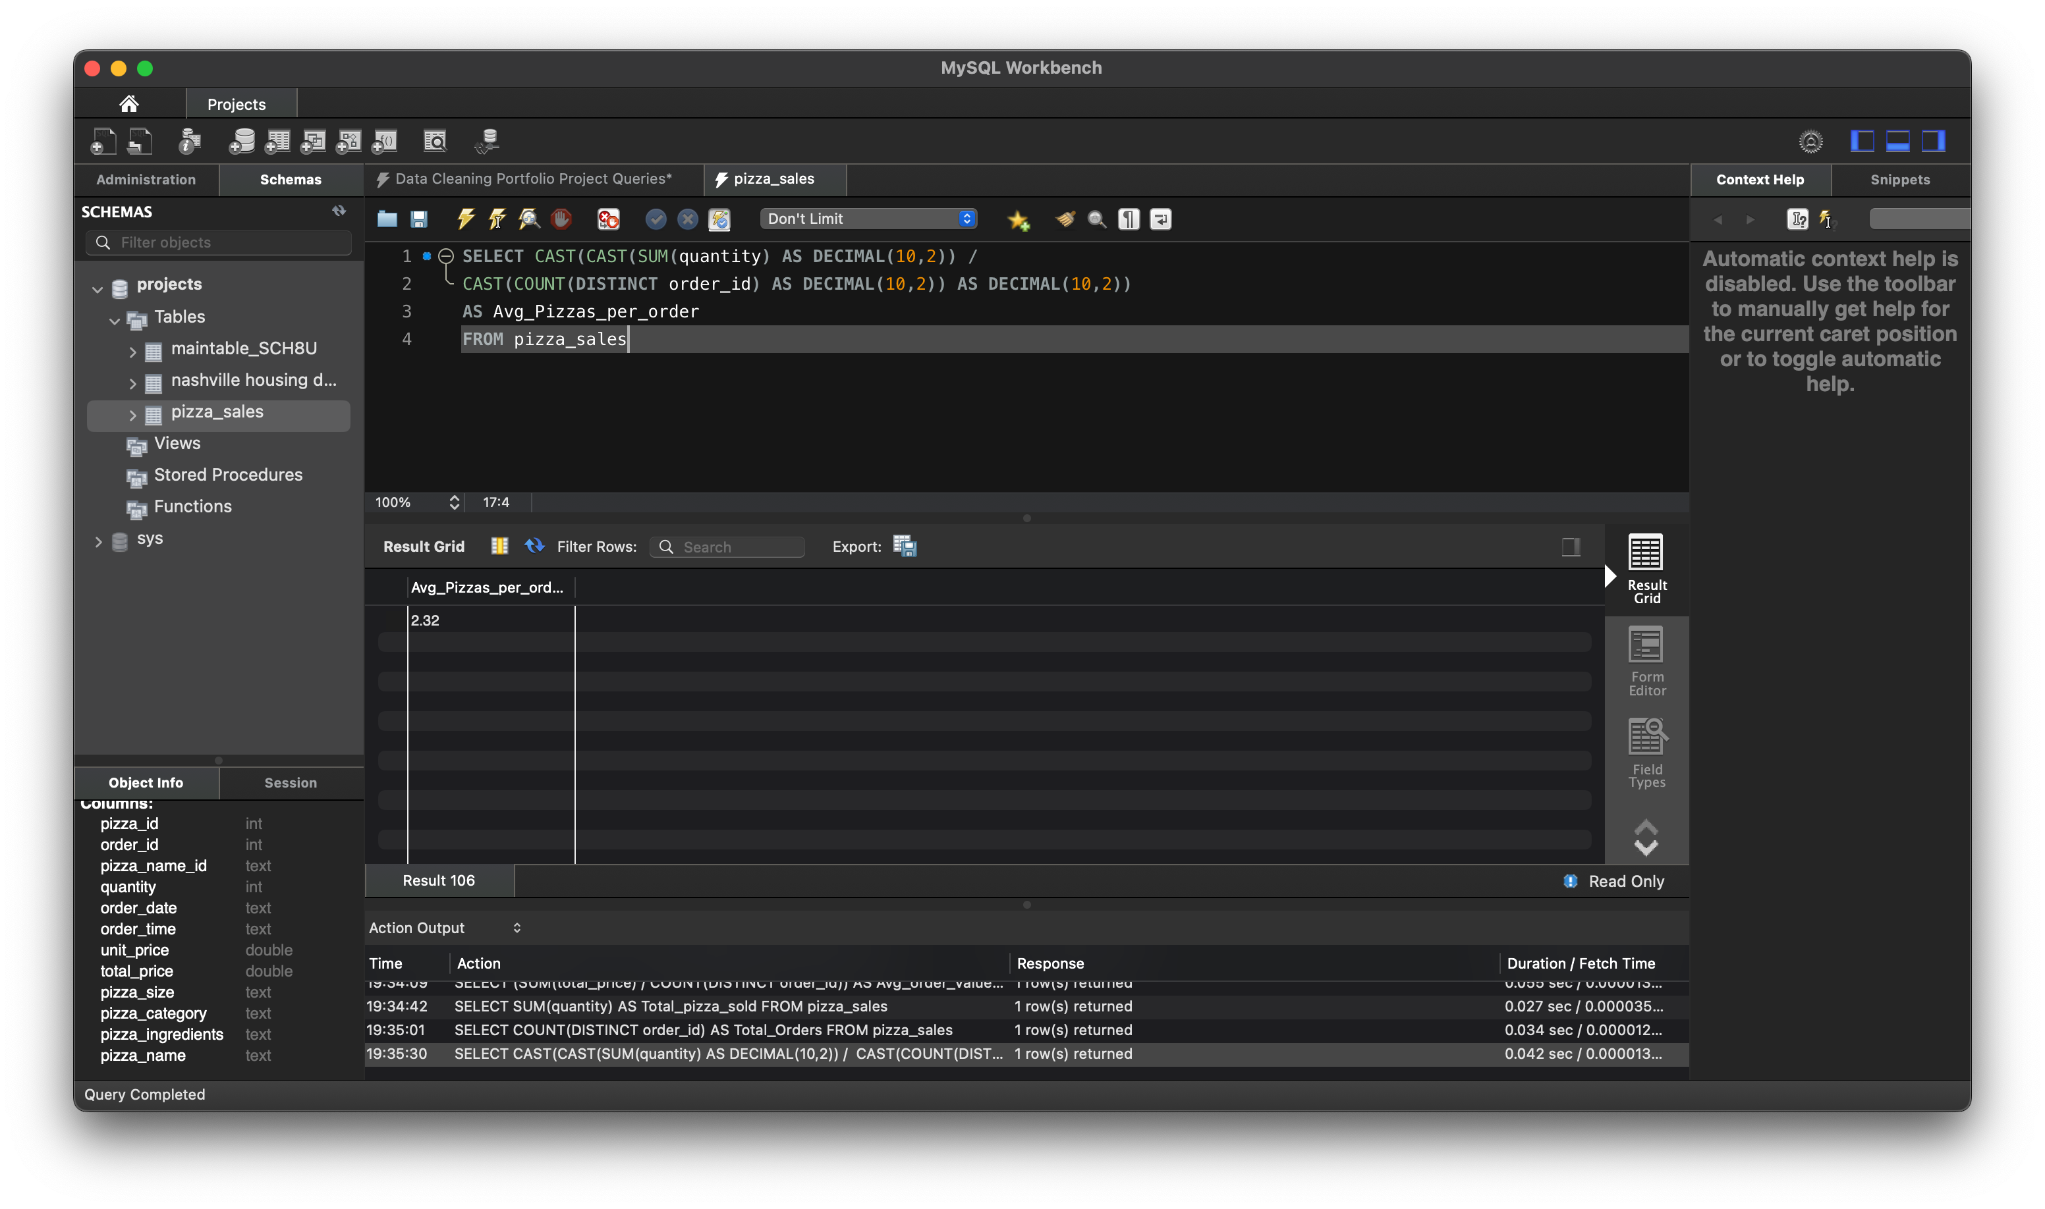

B. Hourly Trend for Total Pizzas Sold

SELECT HOUR(order_time) as order_hours,

SUM(quantity) as total_pizzas_sold

FROM pizza_sales

GROUP BY order_hours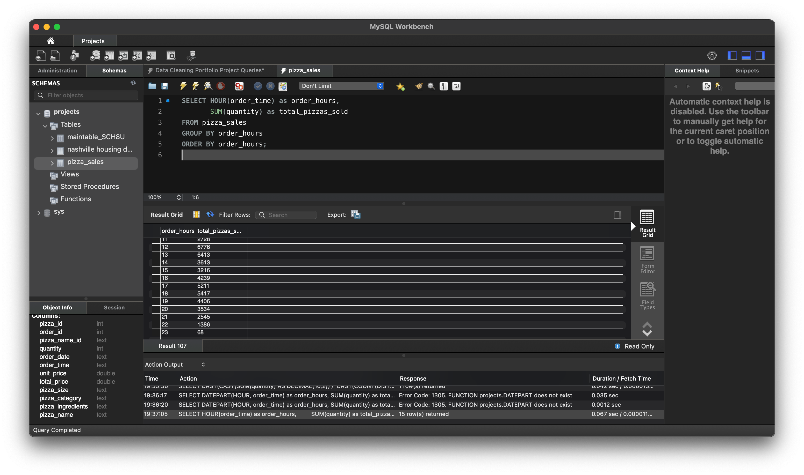

ORDER BY order_hours;

C. Weekly Trend for Orders

SELECT

WEEK(STR_TO_DATE(order_date, '%d-%m-%Y'), 3) AS WeekNumber,

YEAR(STR_TO_DATE(order_date, '%d-%m-%Y')) AS Year,

COUNT(DISTINCT order_id) AS Total_orders

FROM

pizza_sales

GROUP BY

WeekNumber,

Year

ORDER BY

Year, WeekNumber;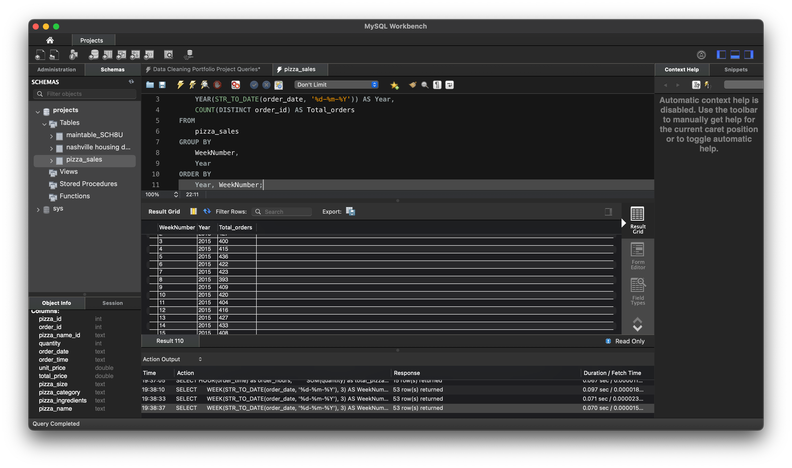

D. % of Sales by Pizza Category

SELECT pizza_category, CAST(SUM(total_price) AS DECIMAL(10,2)) as total_revenue,

CAST(SUM(total_price) * 100 / (SELECT SUM(total_price) from pizza_sales) AS DECIMAL(10,2)) AS PCT

FROM pizza_sales

GROUP BY pizza_category

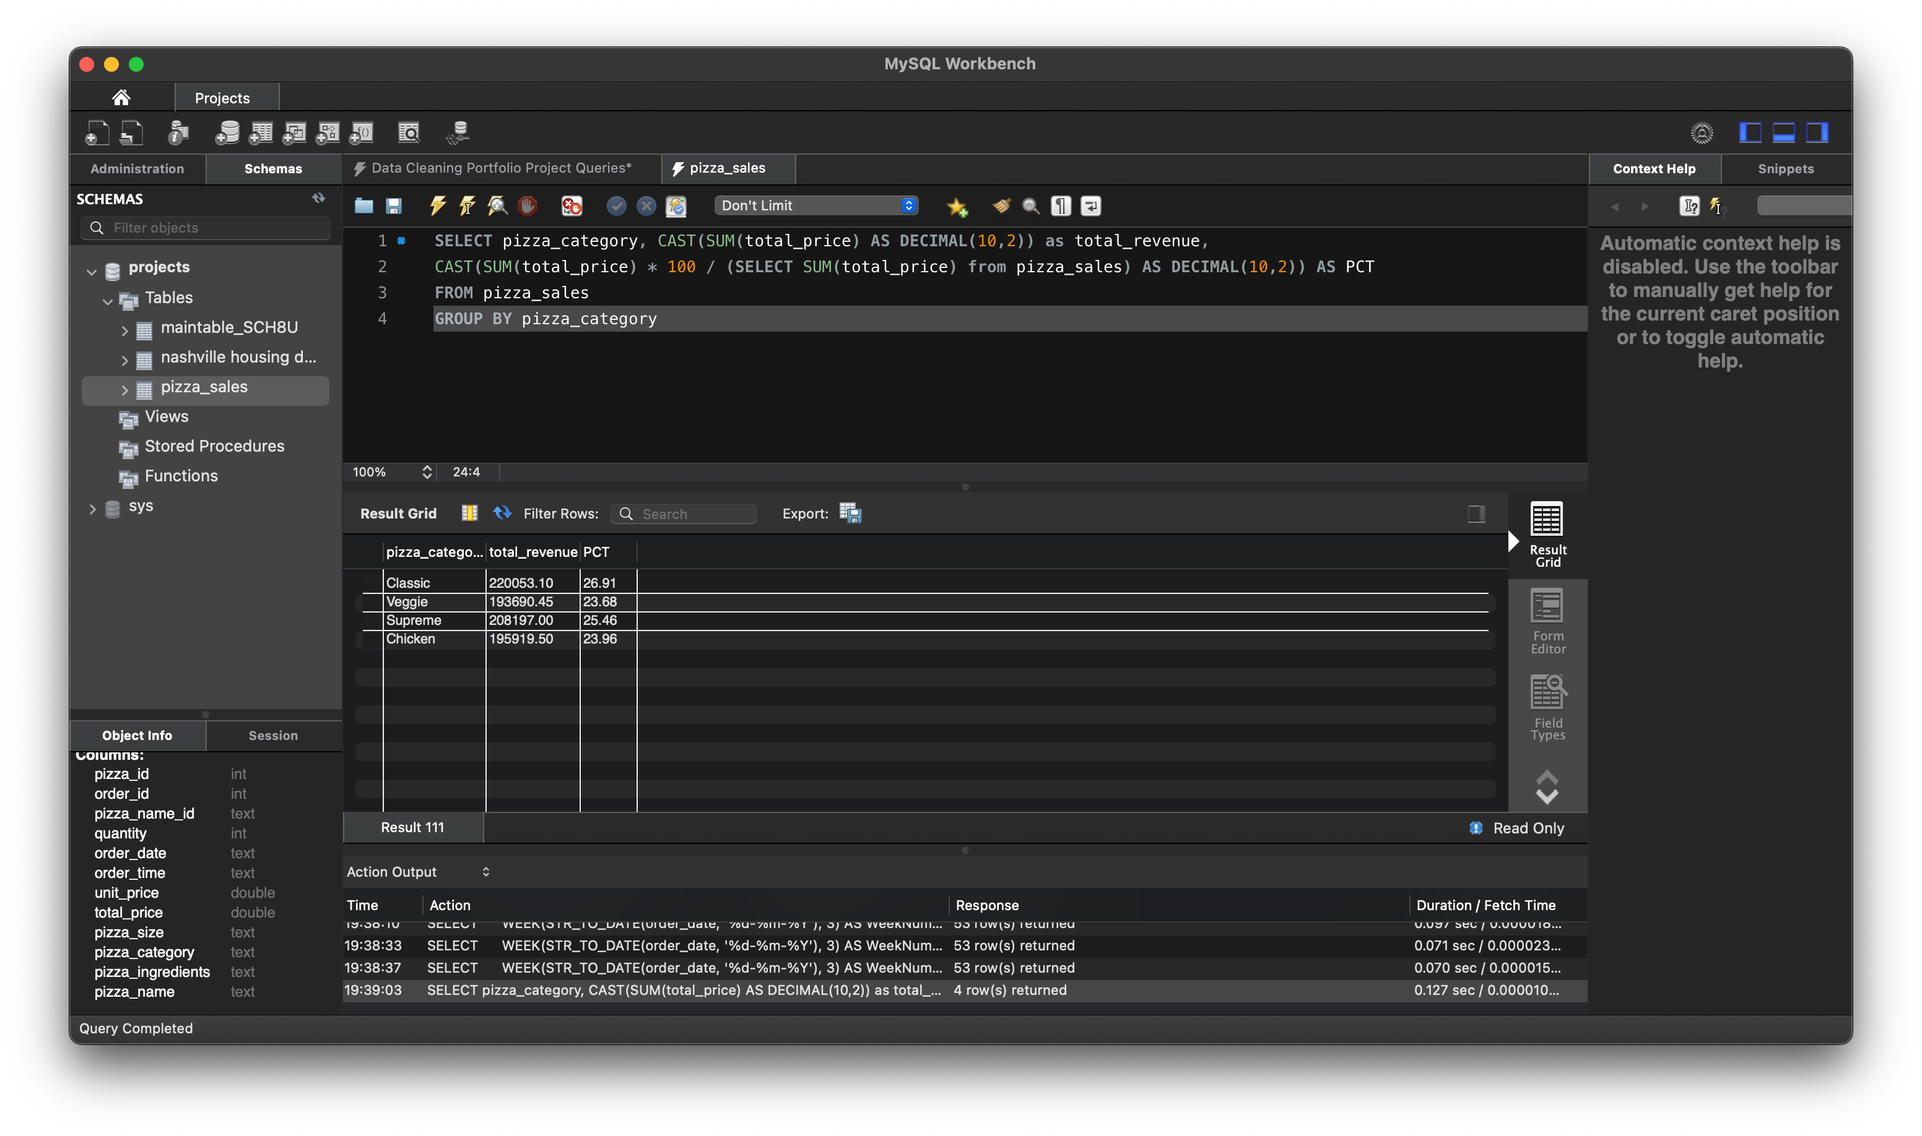

E. % of Sales by Pizza Size

SELECT pizza_size, CAST(SUM(total_price) AS DECIMAL(10,2)) as total_revenue,

CAST(

SUM(total_price) * 100 / (SELECT SUM(total_price) from pizza_sales) AS DECIMAL(10,2)) AS PCT

FROM pizza_sales

GROUP BY pizza_size

ORDER BY pizza_size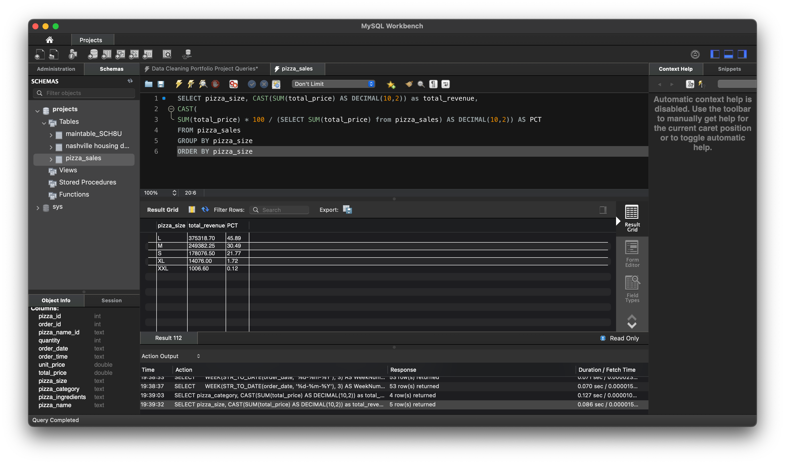

F. Total Pizzas Sold by Pizza Category

SELECT pizza_category, SUM(quantity) as Total_Quantity_Sold

FROM pizza_sales

GROUP BY pizza_category

ORDER BY Total_Quantity_Sold DESC;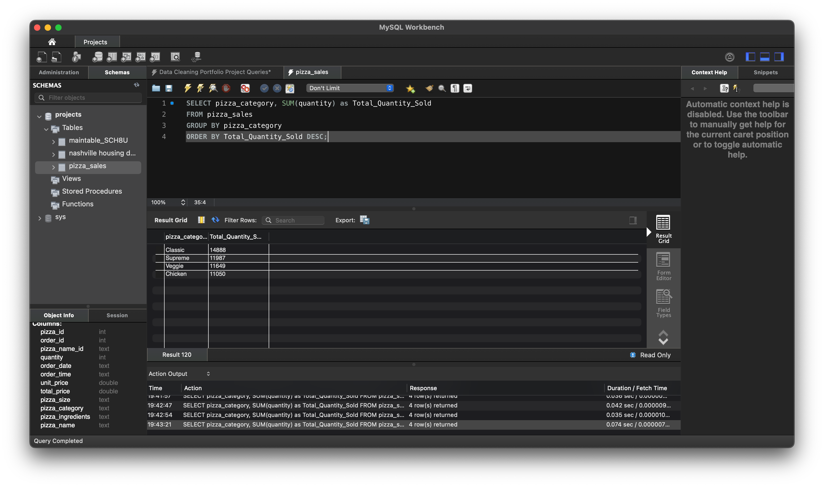

G. Top 5 Pizzas by Revenue

SELECT pizza_name, SUM(total_price) AS Total_Revenue

FROM pizza_sales

GROUP BY pizza_name

ORDER BY Total_Revenue DESC

LIMIT 5

H.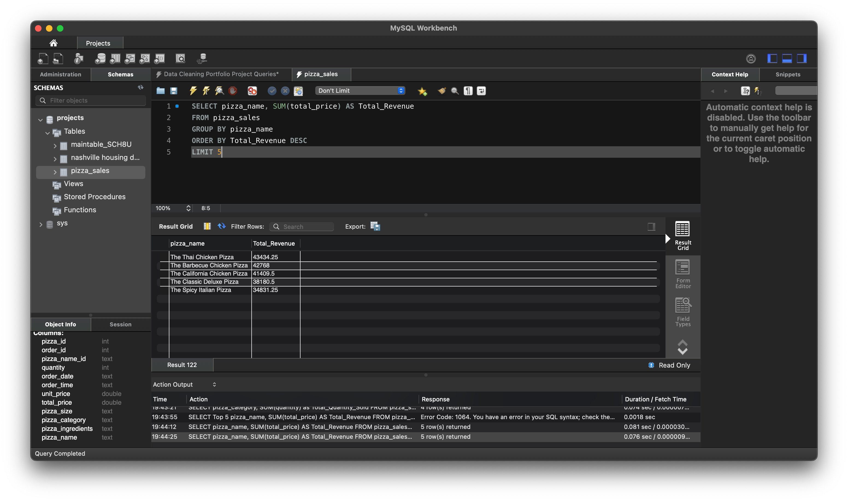 Bottom 5 Pizzas by Revenue

SELECT pizza_name, SUM(total_price) AS Total_Revenue

FROM pizza_sales

GROUP BY pizza_name

ORDER BY Total_Revenue ASC

LIMIT 5

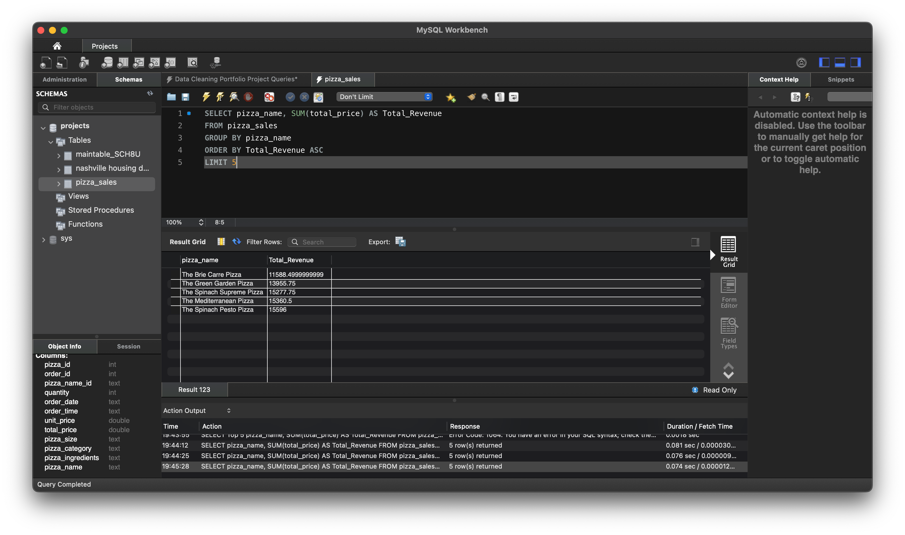I. Top 5 Pizzas by Quantity

SELECT pizza_name, SUM(quantity) AS Total_Pizza_Sold

FROM pizza_sales

GROUP BY pizza_name

ORDER BY Total_Pizza_Sold DESC

LIMIT 5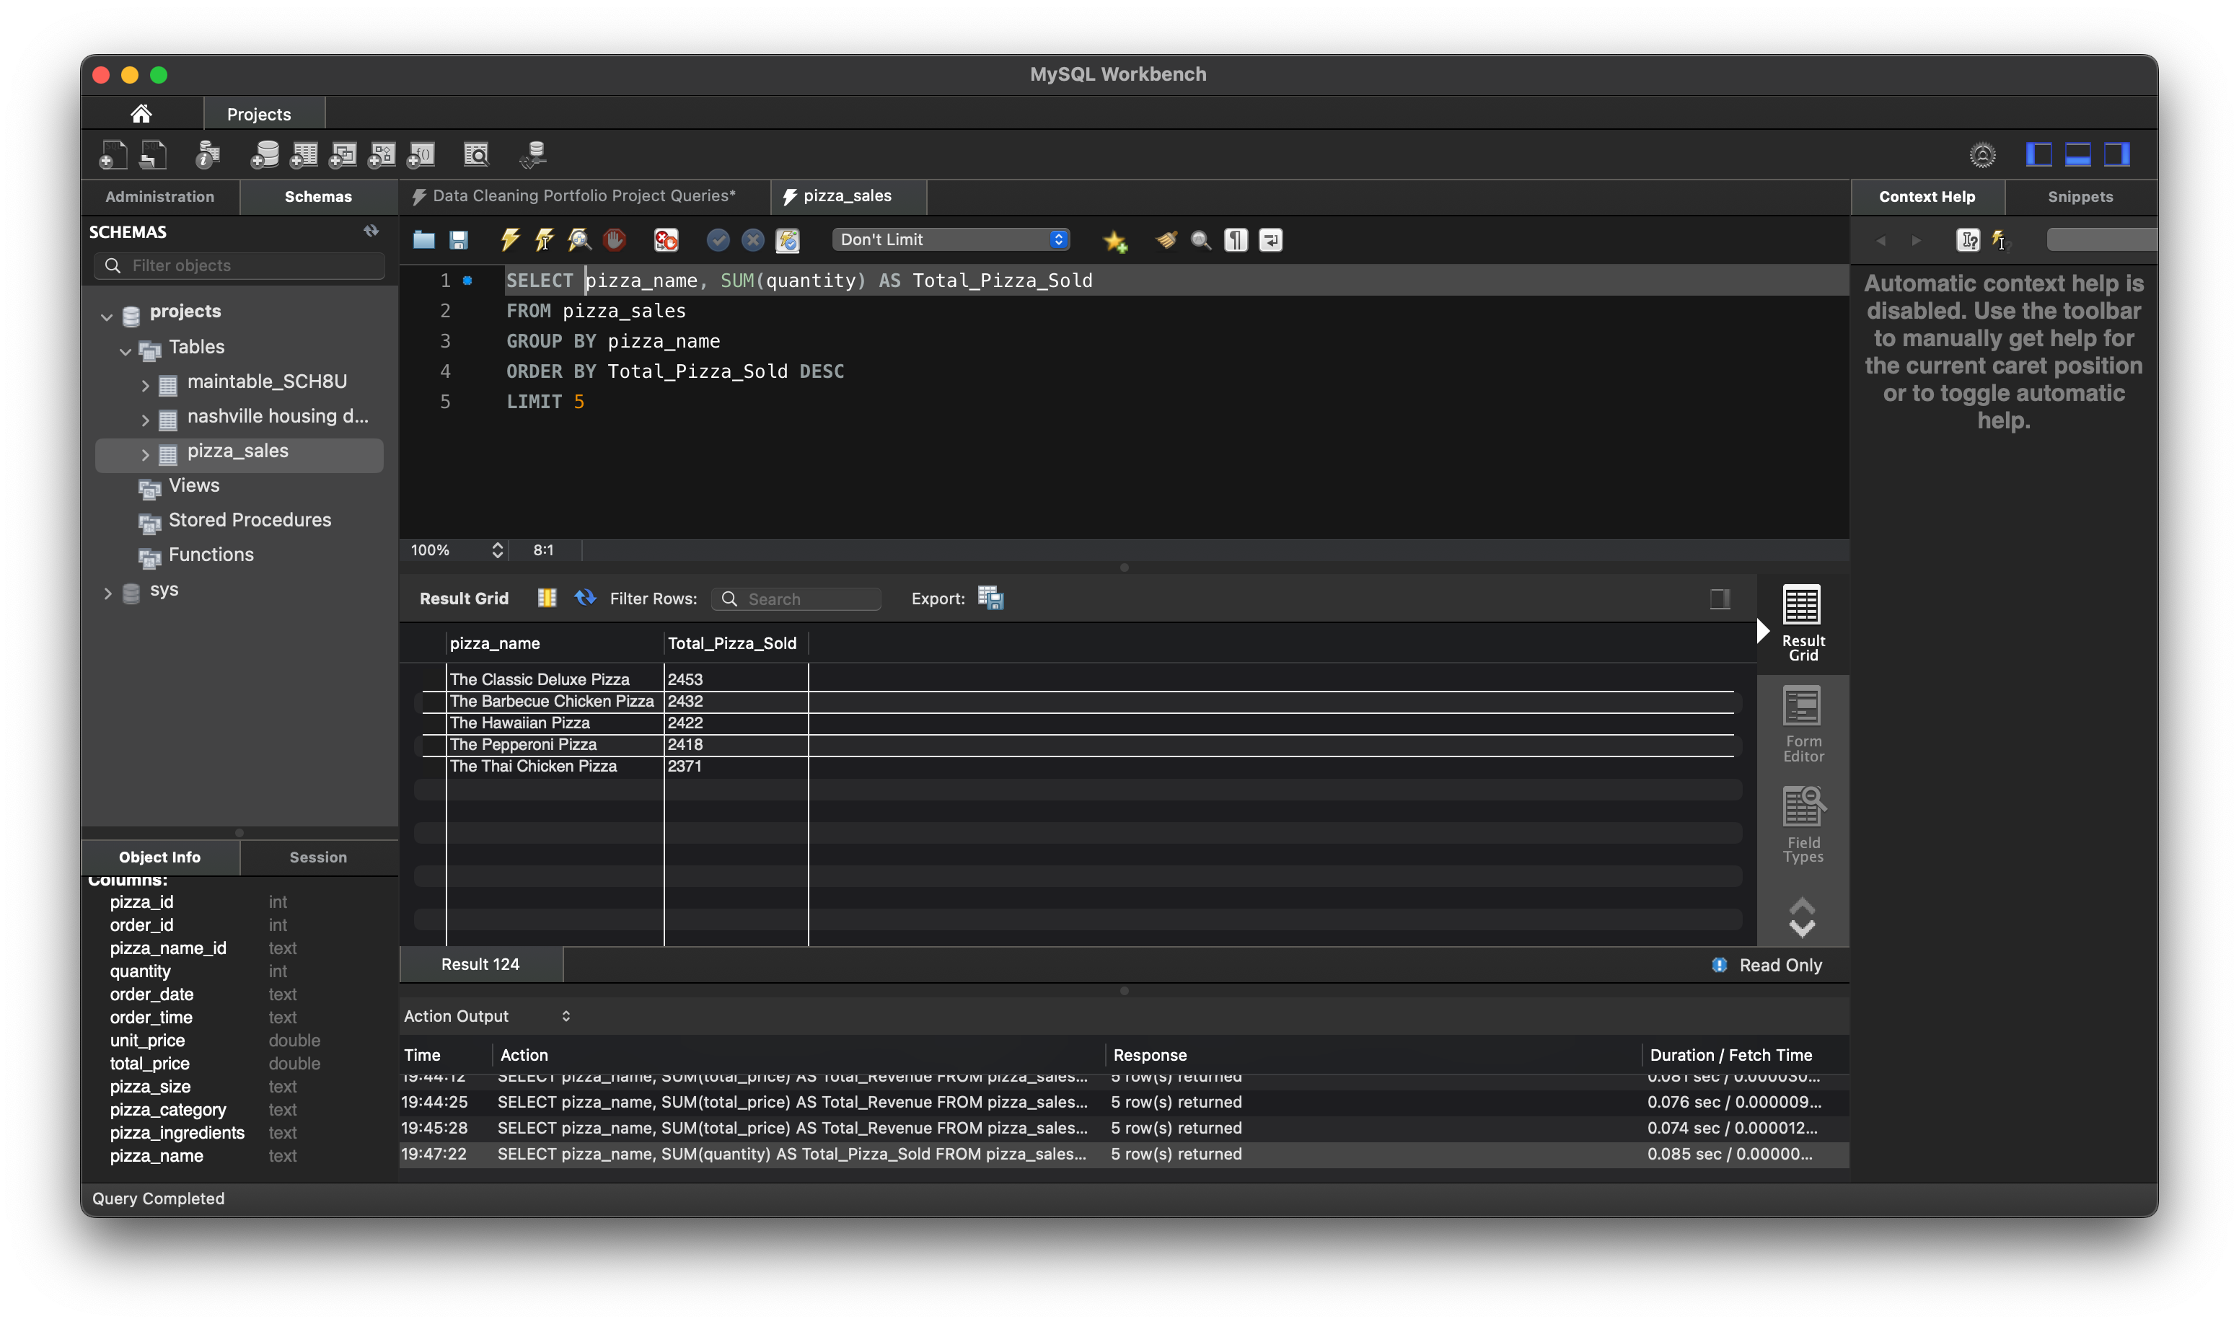

J. Bottom 5 Pizzas by Quantity

SELECT pizza_name, SUM(quantity) AS Total_Pizza_Sold

FROM pizza_sales

GROUP BY pizza_name

ORDER BY Total_Pizza_Sold ASC

LIMIT 5

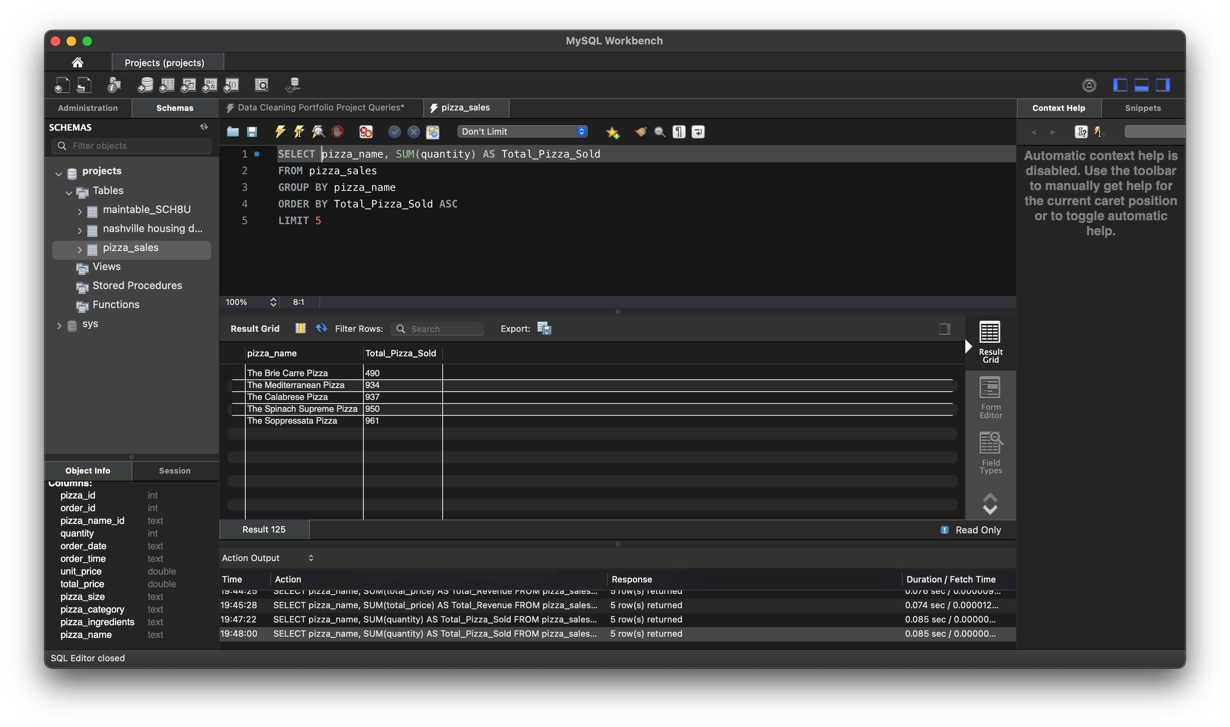

K. Top 5 Pizzas by Total Orders

SELECT pizza_name, COUNT(DISTINCT order_id) AS Total_Orders

FROM pizza_sales

GROUP BY pizza_name

ORDER BY Total_Orders DESC

LIMIT 5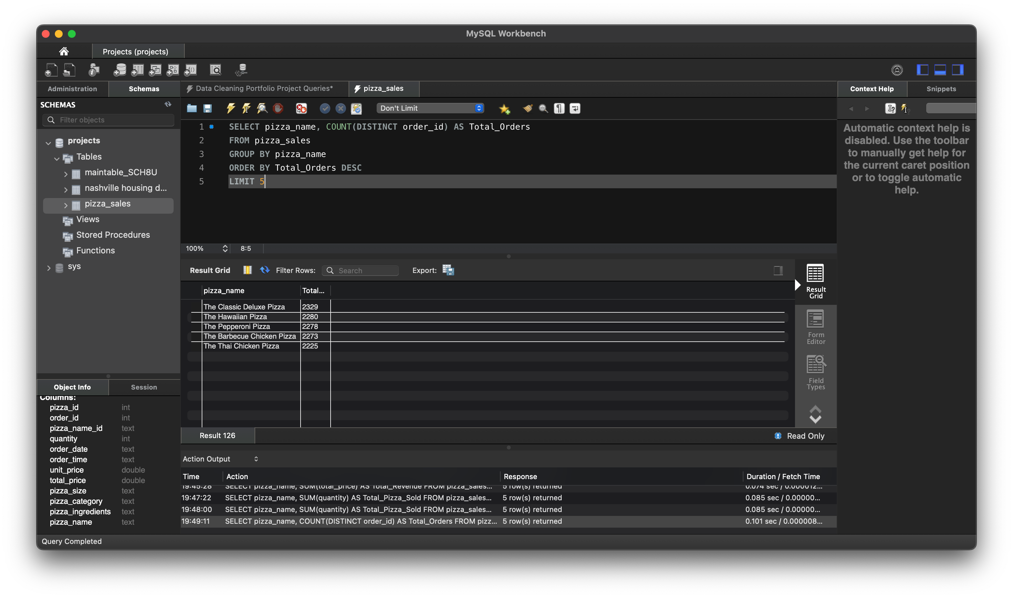

L. Borrom 5 Pizzas by Total Orders

SELECT pizza_name, COUNT(DISTINCT order_id) AS Total_Orders

FROM pizza_sales

GROUP BY pizza_name

ORDER BY Total_Orders ASC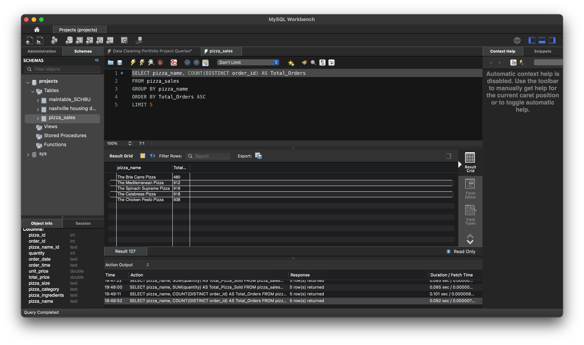

LIMIT 5